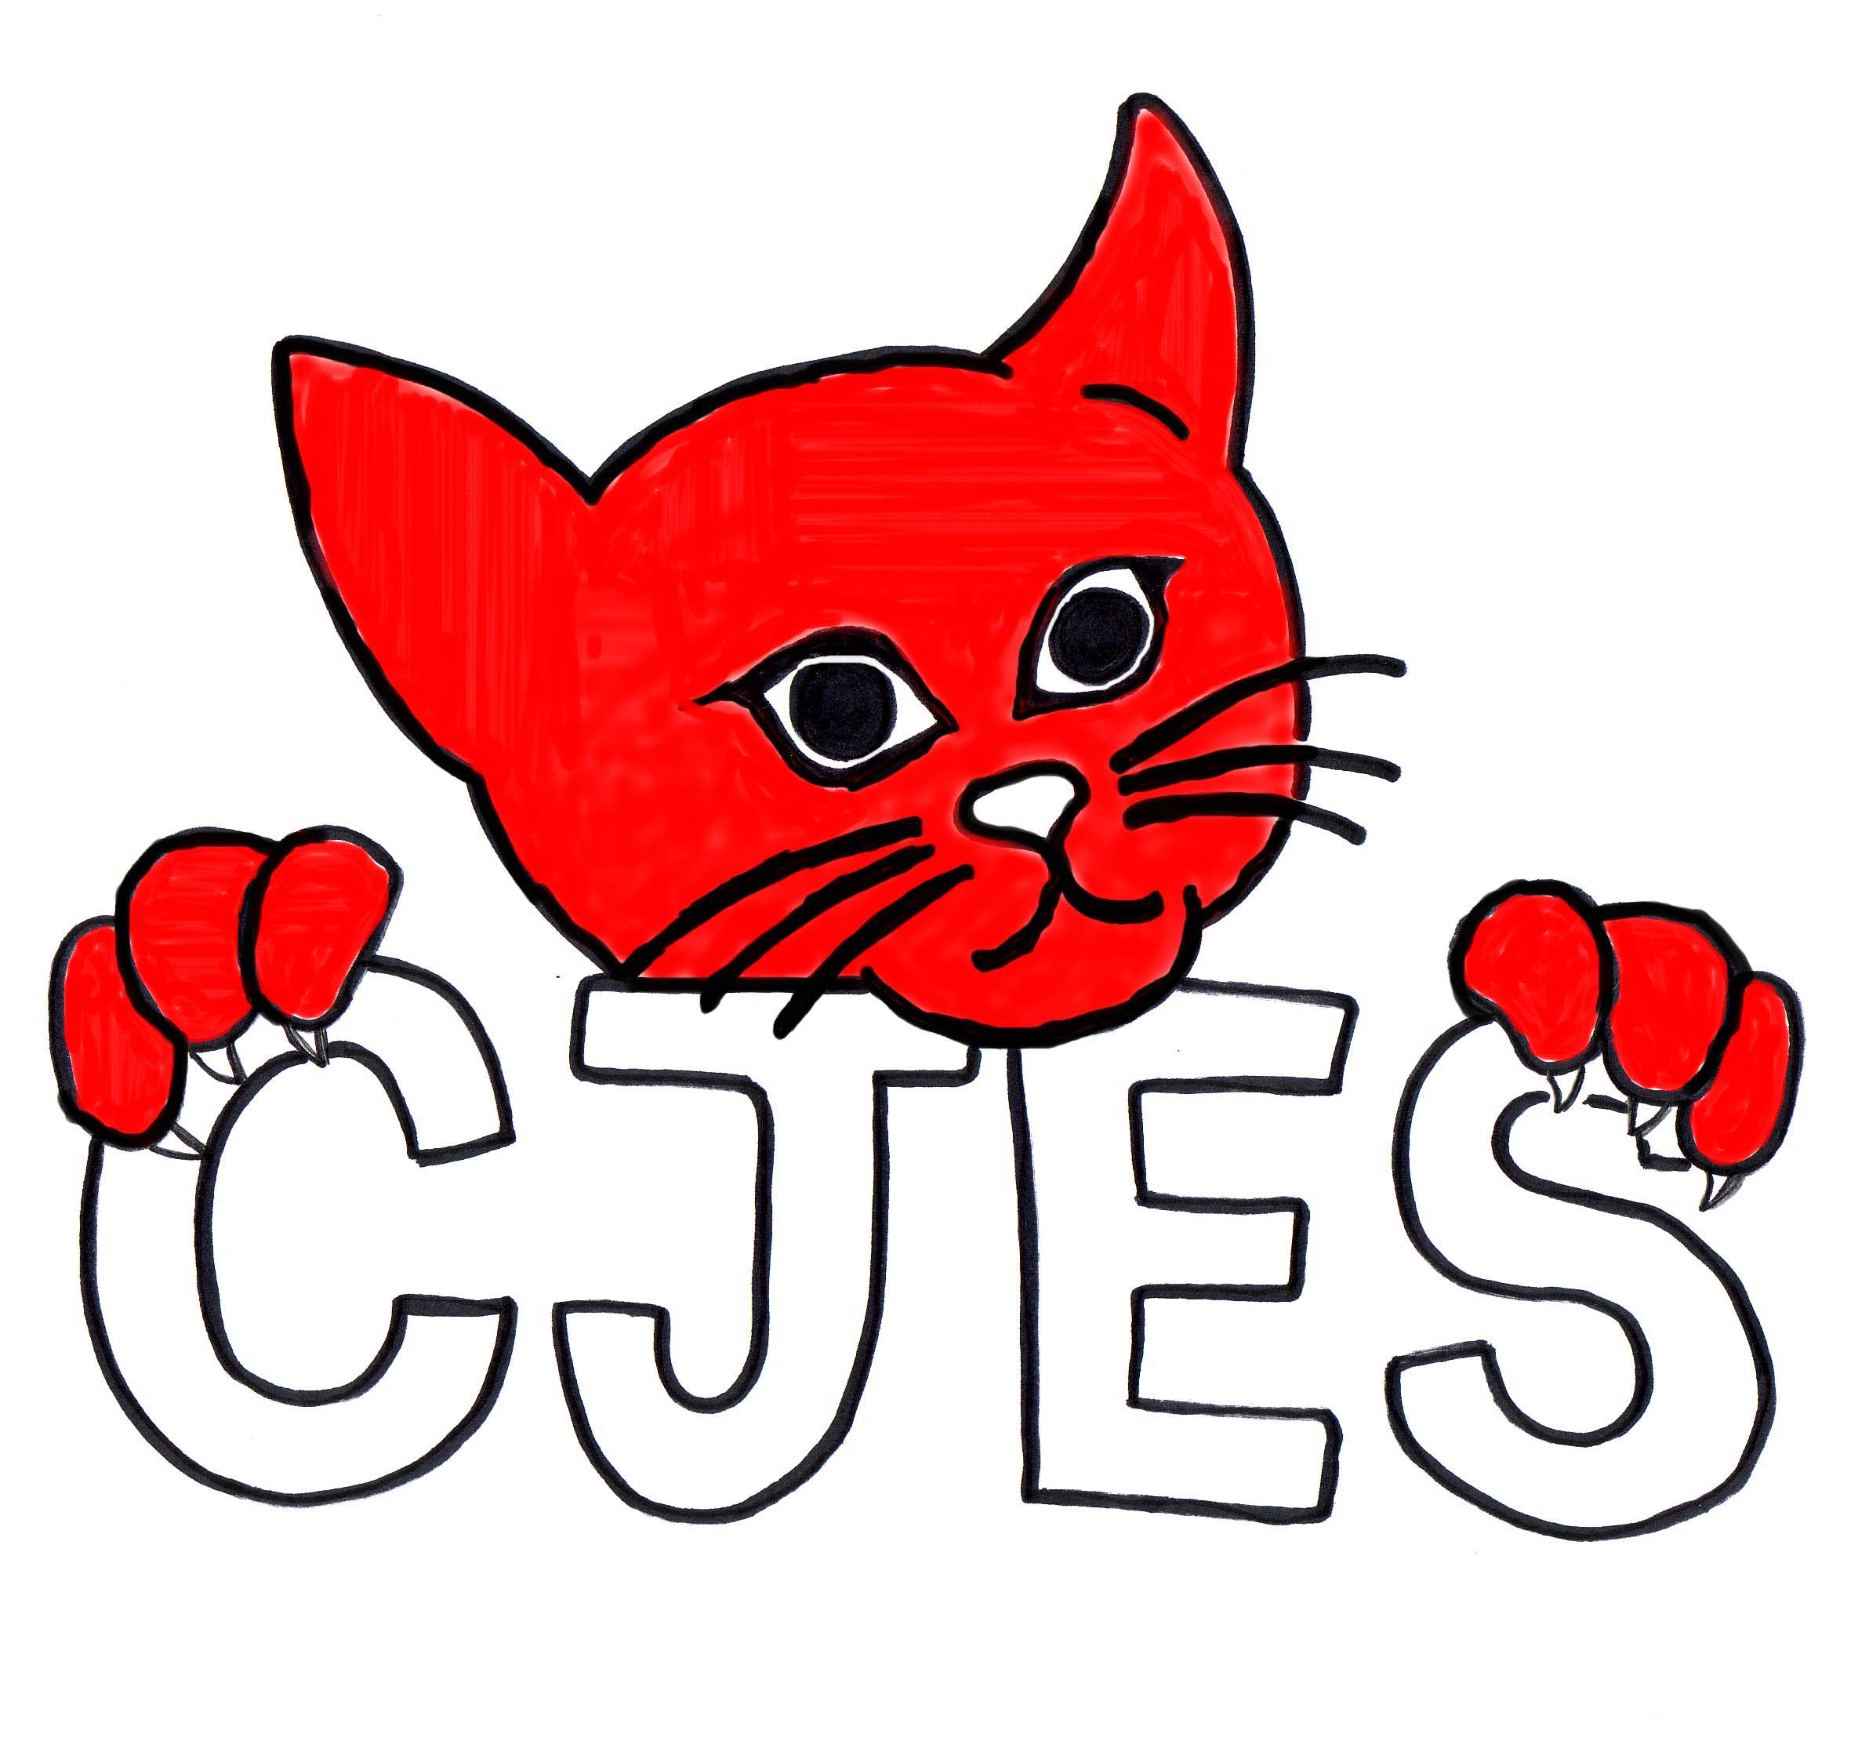
Insert school logo here
School Level Plan
School: CJES School Year: 2021-2022
Component ONE – FOUNDATIONAL ITEMS
Division Motto, Mission, Vision, Values, & Aspirational Statements/Compelling Why | School Mission, Vision, Values, & Compelling Why
Motto – Students Come First
Mission – “Building Strong Foundations to Create Bright Futures”
Vision – “Learning Without Limits ... Achievement For All"
Values – Belonging, Respect, Responsibility, Learning, Nurturing, Perseverance and Diversity

High Quality Teaching and Learning
- Provincial curricula and related resources that are developmentally appropriate and culturally responsive.
- Place play based learning experiences that support a sense of personal competency, self-efficacy, and social responsibility; and,
- A wide range of opportunities to learn, practice, experience and demonstrate understanding, confidence, and motivation for a healthy and balance life.

Engagement of All Students, Families, and Communities
  - Efforts are aligned to promote student, family, staff and community health and well-being.
  - School Community Councils and First Nations Education organizations are involved in School Level Plans.
  - School Leadership values cooperation, effective interpersonal communication and shared decision making.
  - Schools, families, and communities engage in ongoing discussions and shared efforts to promote and support the health and well-being of staff, students, and the community; and,
  - Reciprocal relationships share resources and services within the school and community.
Effective Policy
- Protocols for collaboration on policy development and related protocols practices for health and well-being.
  - Ongoing evaluation and monitoring of needs and effectiveness of efforts to improve well-being.
  - Promising practices that enhance and well-being; and,
  - Clear practices, procedures, protocols and regulations regarding health and safety in children and youth (e.g., nutrition, anti-bullying, physical activity, pandemic planning, air quality).

Healthy, Sustainable Physical and Social Environments
  - Access to and support for healthier options.
  - A welcoming, caring, and inclusive environment.
  - Healthy relationships among and between staff, students, and the community.
  - Responsive and inclusive leadership of staff, students, and community.
  - Relationships that influence and are influenced by families, cultural perspectives, and the community.
  - Modern, responsible infrastructure to maintain and promote the highest levels of support for students, staff, families, and the community.
  - Systems that ensure buildings, grounds, transportation, and technology are built and maintained not only to current standards, but that practices and procedures are in place to plan for a strong, vibrant future.
  - Proactive, innovative approaches to sustain, support and grow Division facilities and systems.
  - Efficiencies, both internally and externally, to ensure appropriate resources are targeted to our key areas including facilities, transportation, and technology.
  - Strategies to use the school buildings and grounds, materials, equipment, and routes to and from the school to enhance well-being of staff, students, and the community; and,
  - Informal role modelling, peer support, nurturing families, and safe communities.

Component TWO – ACTION PLAN
High Quality Teaching and Learning
Division Level | School Level
Division Outcomes | School Level Outcome &/or Work Plans  (Supports Sector and Division) | Evidence of Progress  (How Have You Done?)
By June 30, 2022, 27% more students will exit Kindergarten at appropriate development (green) than when entering Kindergarten. | Testing/Data  a.) Administer the EYE within the first window to all Kindergarten students.  b.) Meet with the RTI Team to discuss the results.  c.) Use EYE data to set classroom goals.  2. Family Engagement  a.) The PK & Kindergarten Teachers will hold 2 family engagement events in 2021-2022. A safe way to do this with Covid will be discussed. They will try Co-plan the event together.  b.) Parent information newsletter from the SLP.  c.) Classroom Teacher sending home additional activities for Early Literacy.  3. Transition PK to CJES  a.) PK to come to CJES for some Gym and Library.  b.) Is there a timeline where PK will come to the CJES building?  4. Resources  a.) Starfall.com subscription – shows mouth formation for sounds, alphabets on the screen, etc.  b) Get the Jolly Phonics book.  c) K teacher will be trained in Heggerty program | This was administered in the Fall  Plans were put in to place to help the students that needed to get to the “green”  Many classroom goals were set. Thanks Laura for all the flexibility, changing the room to meet students needs as the year goes on.  Heather did prek family engagement – corn trails and petting zoo  Laura – Halloween bingo zoom  Plan for spring activity – play date introducing prek to k. Second Family Engagement Day for K’s is May 20th  The SLP’s posted a weekly facebook post with lots of tips for children and speech  Beginning sounds books  Color books with short stories  Prek is coming to library and Gym twice a month  Rod has met with Quinting R., Mark F. and Facilities about this. It is in the works for the new school year.  Went with “handwriting without tears” instead  Got the book/printable and used youtube for songs and lessons.  Done (need program “help me tell my story”)  Laura was given an Ipad and AKSI the turtle
By June 30, 2022, 90% of Grade 1 to 6 students will show one-years growth in their reading levels.  By June 30, 2022, there will be 2% more students writing at or above grade level in Grades 4, 7, & 9 compared to the June 2019 data. | - Sask Reads Document.  a.)Form a Literacy Committee at CJES  b.)Continue the 5 Overarching Principles as a focus for Improvement in the area of Literacy.  - All Students Can Read (Overarching Principle #1)  a.) Timetable so that our SST, VP and K Teacher (Day 2’s) have RTI time to help struggling students.  b.) Form a RTI committee that can be called on to help those students that need more time and support.  c.) Revise and then share/post our Response to Intervention Continuum so Teachers know what to do prior to accessing the RTI team and how to access the RTI team.  d.) Discuss how to best use the Gr. 2 F&P guided reading collection we purchased last year. (Release 1 – Levels E to N for $4000.00 for our interventionists to use).  e.) Have a staff member(s) trained with Heggerty Intervention.  f.) The Literacy Team will review the Guided Reading packages to ensure there are enough resources to support students.  h.) Focus our RTI on our Grade 3&4 students for the first part of the year and then on our Grade 1&2 when they should be ready to take off with their reading.  - The Teacher is Essential in a student’s success in learning to read. (Overarching Principle #2)  a.) Continue with the “Word Study” Program, F&P Literacy Continuum, Guided Reading instruction and creating a culture of learning.  b.) Grade alike teachers continue to work together to provide strong Tier 1 Instruction.  c.) Classroom Libraries with lots of choices and levels.  - Oral Language is the Foundation of Literacy. (Overarching Principle #3)  - Use Technology to arrange Guest Speakers/Readers, Story Tellers for classrooms/Whole School.  - Balance is Important in Reading Instruction (Overarching Principle #4)  a.) Purchase a subscription to Raz Kids.  b.) Continue with One School One Book.  - Family and Community are Critical Partners in a student’s reading success. (Overarching Principle #5)  a.) Figure a way to involve the families in “one school one book” so they are part of it. (Covid Protocol consideration).  b.) Posting Reading Ideas on FaceBook.  c.)Use of Facebook, Blogs, Seesaw and Newsletters.  - Utilize Resources for Writing.  a.) Have Bump it up walls or Exemplars or Writing Samples so students can self-assess where they are at.  b.) Use of the Ministry Writing Continuum and F&P Word Study.  c.) Make Teachers aware of the Jennifer Sarravallo book we have “The Writing Strategies Book”; The Adrienne Gear book we have “Writing Power” and the Writing Strategies Book by Lori Rog.  d.) Sigmund Brower – Writer in Residence online resources.  - Access Resources on the Portal such as the writing anchor activities, Ministry Writing Continuum, Word study, GSSD Analytical Writing Rubric, Exemplars.  2. Classroom Tier 1 Instruction  a.) Writer’s Workshop  b.) Use of Technology to enhance Writing.  c.) “Alpha Blocks” & “Super Why” are great videos to show over lunch. | Done- thank you Lisa, Bev and Patti-Jo  Done  Done  Done, thank you Kendra, PJ and Laura  Done, thanks for sharing this at the Oct. Staff Mtg. Kendra  Done – All Staff can use this resource  Done – thanks Laura, PJ and Kendra  Done-Decodables have been purchased and we will continue to support the collection by purchasing more when money is available.  Done and continuing through the current school year as student needs adjust.  Heggerty phonemic awareness activities  -Intervention  -Use Decodables  -Rime Magic  -Grade 1&2 Intervention  -Sound Walls that focus on sound/symbol relationship and speech production of the sound  -Decodable books have been purchased for classroom use and pulled for use from existing collections for all grade levels  -Lindsey Propp (Willow Awards)  -Betty G. Birney, the author of the “Humphrey series” sent us personalized videos to use with our OSOB program in January  -February- teachers will access the resources for Indigenous Storytelling Month  Done - $1000  Done. Started Jan. 17th and ended on Family Lit Day Jan. 27 – The book will be “Humphrey”  Each family received a book package to participate with. We had 47 families return their BINGO sheets from grades 1-4 on family literacy day.  OSOB was promoted on our CJES Facebook page.  OSOB allowed us to create a school-wide “buzz” about literacy. Many positive comments from students and families.  -teachers are using these resources  -portal.gssd.ca, teachers are using these resources  Show at a staff mtg./include the book “The Writing Revolution” ask if staff have found any other resources they like  -order the book “Making Writing Instruction Work by Brenda Augusta  -books used in Tier 1 instruction as a novel study/ books available in the library  Portal.gssd.ca for online resources  -teachers are using these resources, GSSD portal has a “Writing Instructional Framework” section with links to many useful resources.  The writing tab in the portal has a document that has broken down the ministry writing continuum into grade levels for easy teacher access to essential skills- share at the staff meeting  -used in Tier 1 instruction, OSOB provided opportunities for students to write in response to Humphrey’s journal comments  -Word Wizard/apps for spelling/Word Work  On-Going students really enjoy this
By June 30, 2022, there will be 2% more Grades 2, 5, & 8 students at or above grade level in math compared to the June 2019 data.  By June 30, 2022, the number of students in Grades 4 to 12 reporting high levels of anxiety will reduce by 2% from spring 2021 data. | 1. Capacity Building/Professional Development for CJES  a.) Form a Math Committee at CJES and Give them a Budget to work with.  2. Continue to Strengthen Tier 1 Math Instruction.  a.) Math Room to be organized to make it easier for teachers to have the resources they need.  - Math Committee will work to make sure manipulatives and materials for teachers are available.  - Mathology in Grade 1 & 2  - Knowlegehook in Grade 3 & 4  - Number Talks in all Grades  e.) Use of Seesaw  f.) Grade 2, 3 and 4 to complete the Math Screener.  g.) All Teachers to use the GSSD Analytical Math Rubric.  h.) All Teachers to use the Pre-Math Assessments from the Ministry.  2. Make Math Fun For Students  a.) Put together a math trail through the community and link technology with this.  b.) Put on “number blocks” will the kids are eating (K-2)  c.) Math intervention Time so math comes easier for students.  1. Capacity Building in the Student Well Being Area of “Reducing Anxiety”  a.) Put a CJES Team in place known as the “Student Well-Being Team to actualize this section of the LIP.  2. Reducing Anxiety via Environment/Culture of calming and caring.  - Beginning of the year Zoom Assembly to show students they are in a helpful supportive environment  - Staggered entry at the beginning of the year in PK & Kindergarten.  - Incorporate more fresh air breaks throughout the day like a walk around the playground, yoga on the playground  - Terry Fox Run – Good activity for the students.  e.) Mindfulness videos like Cosmic kids yoga and “Go-Noodle” for relaxation and centering in the classroom.  f.) Outdoor Classroom Opportunities  g.) Make a playground schedule where students can cohort with their entire grade rather than just their class this year.  h.) Assign Grade 4 “Bus Buddies” to our Kindergarten’s to reduce their bus line anxiety.  i.) Form a Grade 4 SLC (Student Leadership Council)  j.) Staff-students connecting in the morning through greetings before the class starts.  k.) Help Mrs. Donovan with her Sensory Room Goal to better assist all students in the school  3. Reducing Anxiety via School Garden.  a.) Form a Garden Committee to better tie the garden into the curriculum and our anxiety goal.  b.) The Garden committee will also look into moving along our Outdoor Classroom opportunities.  c.) Put the school Garden as one of the scheduled playground spots this year. Have someone open the playground at the beginning of the day and close it at the end of the day so students have access.  d.) Gr. 4’s to partner with CCS again to plant at the CCS garden and visit to see it grow.  4. Reducing Anxiety via School Nutrition.  - The kitchen is closed to students coming to the kitchen due to Covid protocols. Assign Supervisor #4 to help out if a student doesn’t have lunch.  - Keep bread, peanut butter, apples, cheez-whiz and jam on hand. This could be delivered to the student in the classroom. | Thank you Jenn, Lindsey and Rhonda  Thank you Bev for your work in this area  Thanks to the math committee for keeping our math resources up to date  Teachers are using this Resource  Teachers are using this Resource  We have ordered the book for every class. See Mrs. Prychak if you need us to arrange coverage and have her work with you on Number talks.  Seesaw is Ongoing.  Thank you teachers. The Screener Data has been submitted for Fall and the Spring.  Grade 2-5 Teachers attended a Division Directed Math PD about the Analytical and Holistic Rubrics on Feb. 1st.  Portal.gssd.ca  Thank you for organizing the Jenn and Lindsey  The kids seem to love this.  The has been built into Laura’s RTI time on Day 2.  Thank you Alex, Rod and Kendra  This was done on the first Friday of the School year. Students got to virtually meet all of the staff in the school and new students were introduced  Done according to the Division calendar. Still large groups in Kindergarten even though they were split.  Fortunately it has been a nice fall, lots of classrooms continue to take advantage of this.  Thanks you Mrs. Prychak and CCS for making this a successful activity. ______ was raised.  Some of this was shared to parents as well when implementing AP 206 Opening Exercises  -Alex will attend the next SCC meeting to share plans regarding an outdoor learning space.  An outdoor schedule has been made. It has been shared and posted at the entrances. Students are starting to get the hang of it.  Bus buddies have been assigned to the K’s. Thank you to Ms. Blender and the Gr. 4 teachers as well as Teachers in charge of bus lines for organizing this.  The SLC is well underway. Thanks Kendra and Rhonda  Thank you teachers for opening the entrances when the bell rings and meeting students at your doors.  The Sensory room is coming along nicely. We may need a tour. Thanks Mrs. Donovan.  Thank you Alex and Lisa  The Outdoor Classroom Idea was shared with the CJES SCC in November. Ms. Blatter wants to be on the agenda regarding this again in May.  This spot is shared with open field. Thank you Lisa for picking up all the beach toys that students have been enjoying when they are in the garden. Thank you Rox for weeding the garden so students can play in it.  Thanks to CCS for inviting us over on Wednesday, June 8th to have our 4’s plant.  Supervisor #4 is part of our lunch supervision schedule.  There continues to be a need for this spot. It is working well.  Thank you Kim for keeping the snack cooler full.
By June 30, 2022, students in Grades 4 to 12 will report a 2% increase in student intellectual engagement from spring 2021 data.  By June 30, 2022, GSSD will demonstrate a commitment to provide professional development and training to its staff based on the four Aspirational Statements. | - Lots of movement breaks and mask breaks.  b.) Get to know our students. Build relationships.  c.) Start up clubs/extra curr. again depending on Covid protocols.  d.) More Ipads needed - Use technology to keep students engaged and enhance their learning opportunities.  e.) Flexible seating  a.) 3 meetings with staff to discuss PGP’s and exploration of the PDP continuum. | Fortunately it has been a nice fall, lots of classrooms continue to take advantage of this.  Let the Student Well Being committee know if we can formally match a student in need of an adult’s attention with a staff member.  We were able to run outdoor extra-curr (Soccer & XCountry and hosted our first XCountry tournament).  $3000 Grant awarded to SCC. $7000 donation from SCC. $1000 donation Titan Pipeline Services LTD.  Lot of different flexible seating has been used in the classrooms.  Sign up for Division and School Based PD – Done Oct. 12, Jan. 31, Feb. 1

Engagement of All Students, Families and Communities
Division Level |  | School Level
Division Outcomes | School Level Outcome &/or Work Plans  (Supports Sector and Division) |  | Evidence of Progress  (How Have You Done?)
By June 30, 2022, all students will achieve a 2% increase in student attendance based on the June 2021 data. | a.) Send out the GSSD Attendance letter that reiterates the importance of regular attendance.  b.) Find out the root cause of families not attending and remove that barrier with a “how can we help” approach (lunches, clothing, vehicle, etc.).  c.) Connect with families, be supportive & provide engagement.  d.) Continue to purchase lice treatment stuff.  e.) Get a clothing closet together.  f.) have staff check data warehouse for patterns and red “hotspots”  g.) In consultation with the Supt. of Operations develop strategies to contact parents. |  | This was sent out at the beginning of the school year.  We continue to phone, ask how we can help, do home-visits, break the day down to smaller sections, Liaise with family support workers. Lindsey Propp has been a big help in this area. We still have work to do here to get all students in the building.  Edsby, Seesaw, Messenger, Classroom Blogs, Phone calls  We have done this several times this year.  -The thrift store said they would help with supplies for students/the closet. Many donations were given.  We have found a lot of patterns… mainly Covid and year to year Chronic non-attenders  Mark is very aware of our attendance patterns
By June 30, 2022, GSSD will increase our organization’s cultural competencies through division-wide processes and professional learning that grow our collective understanding about Indigenous identity, histories, worldview, and systemic barriers.  By June 30, 2022, GSSD will demonstrate a commitment to the establishment of new and reaffirmed partnerships. | a.) More awareness of Orange Shirt Day.  b.) Staff member to organize purchase of Orange shirts for those that need one.  c.) Students and Staff really enjoyed the online sessions with FN content that Jesse Armstrong organized.  d.) Waneskawin is a great resource.  e.) FN section in the library and Professional stuff in the cupboard. Continue to use this and build on it.  f.) New VP Kendra Simon has connections and may be able to get and elder, etc. in.  g.) CBC kids has really good things to explain “indigenous” and what that means.  h.) Medicine Wheel for all staff - $5 per month  i.) Show the video recommended by Mark F. at a staff mtg “Understanding and finding our way: Decolonizing Canadian Education – you tube”  j.) Get trained with the Seven Sacred Teachings Resources – C. Delorme  k.) Can do more with “Aksi” turtle this year, last year the kids couldn’t touch it.  l.) Take part in the “GSSD 2021 Reconciliation Challenge”  m.) Get presenters in to help students gain an appreciation/education with Truth and Reconciliation.  a.) CJES looks forward to reaffirming partnerships with local community groups – walking paths, fire-dept. RCMP, museum, greenhouse, museum. |  | Staff ordered shirts, great resources were shared and students took part on many levels.  Thanks you to Laura and Lindsey for putting this order together  Students were able to access the morning session through zoom. Thanks  Thanks for sharing this Lindsey.  Bev Keeps updating, thanks. Thanks for the resources you posted in “Edsby – All Staff Alex”  Kendra spoke with both Stella Pelly/George Musqua and both are willing to come in when we are ready.  Thanks for sharing this Lindsey.  Thanks for sharing this Lindsey.  See Rod/Kendra if you would like a subscription.  This link was shared with all staff.  Rod reached out to set up a time to do this over zoom. We would still be excited to do this next year as well.  Laura did the training and story assessment and the Puppet play with Aksi  Thank you Kendra for organizing this activity.  Thank you to everyone who shared resources and took part in the activity. It was submitted to GSSD.  “Dancing Horse” presentation at CCS  CJES bought the Fire Dept. a large amount of Tim Hortons and Rod delivered this to the Fire Hall after the early morning heater fire in the new end. Police are part of Safety Patrol training.

Effective Policy and Procedures
Division Level | School Level
Division Outcomes | School Level Outcome &/or Work Plans  (Supports Sector and Division) | Evidence of Progress  (How Have You Done?)
By June 30, 2022, each functional area within GSSD will demonstrate improvement in services through the development, review, and revision of administrative procedures that reduce barriers and enhance student success. | a.) When draft AP’s are released CJES Staff will have an opportunity to provide feedback. | Rod will share the Friday File link with the staff when it comes through every week.
By June 30, 2022, each functional area within GSSD will demonstrate improvement in services through the development, review, and revisions of processes that reduce barriers and enhance student success. | a.) During staff conversations we will seek out ways to remove barriers for student achievement. | Not having to pay school fees if parents are having a difficult time.  Wifi and Technology to families in need.
By June 30, 2022, GSSD will implement systemic and transparent approaches to find efficiencies and increase value for money allowing the Division to respond to the challenges of student and staff needs. | a.) Review budget monthly.  b.) Admin. Team will delegate dollars to classrooms and LIP teams and areas specific to our school. | Rod & Kim continue to do this.  This document has been completed and shared with staff.

Healthy, Sustainable Physical and Social Environment
Division Level |  | School Level
Division Outcomes | School Level Outcome &/or Work Plans  (Supports Sector and Division) |  | Evidence of Progress  (How Have You Done?)
By June 30, 2022, students and staff will report feeling welcomed, included and feel a sense of belonging and caring at school. | a.) Greet students and staff outside in the morning and after school.  b.) “Our School” Data gathered in spring by our school.  c.) During covid time we could use zoom/teams to connect with families with school events when necessary.  d.) Staff will connect with parents for 3 reporting periods or if needs arise. |  | Staff continues to do this.  This survey was completed in May and the data has been shared with everyone.  We had to move SCC mtg to virtual again in January. Virtual meeting were an option for our first “parent-student-teacher update week in November.  We used the schoolinterviews.ca program this year and it worked very well for parents and teachers to connect at a mutually beneficial time.
By June 30, 2022, students and staff will develop mental fitness (state of well-being and having a positive sense of how we feel, think, and act) to identify emotions and access supports. | a.) Implement Friends at Grade 1 & 4  b.) Implement “We thinkers” into classes that would benefit  c.) Share monthly health and wellness letter from the counselors.  d.) The school has developed and will continue with language around zones of regulation  d.) Remind staff and students that they have access to the school counselors or other counselors in the Division.  e.) Administer “Our School” and “SOSQ” to our Grade 4’s in the Spring. |  | Everyone is trained. Rod is partially trained.  A number of classrooms are doing we thinkers and using the language/zones.  These are shared with staff on a regular basis.  Done  This continues to happen.
By June 30, 2022, students will receive timely and responsive evidence-based prevention and intervention services at school. | a.) TERT group has been developed to support staff and students at CJES.  b.) Based on need but a minimum of 4 times per year school personnel will meet with PSP providers to support students when needed. |  | This group was put together in the fall  Many such meetings (more than 4) have already taken place based on need.
By June 30, 2022, students and families will report that they know where to turn for more intensive support when needed. | a.) If parents are in need in consultation with Lindsey Propp and the school team parents will be provided information regarding their needs. |  | This continues to happen

Component THREE - THE REVIEW PLAN
Three times per year, the school team should unpack their LIP. Emphasis should be placed on results. The following questions may be used as prompts for discussion.
- What is on and off target?
- What do we need to adapt in our plan?
- What can we do to be more effective as a team?
- What can I do to be a more effective team member?

Component FOUR - THE COMMUNICATION PLAN
How will the plan and progress be communicated to the school community? Note, a copy of the signed School Level Plan will be posted on the school website.

In-School Administrator(s) Signature | Date
School Community Council Chairperson Signature | Date

Learning Improvement Plan Resources
Strategic Plan Cascade
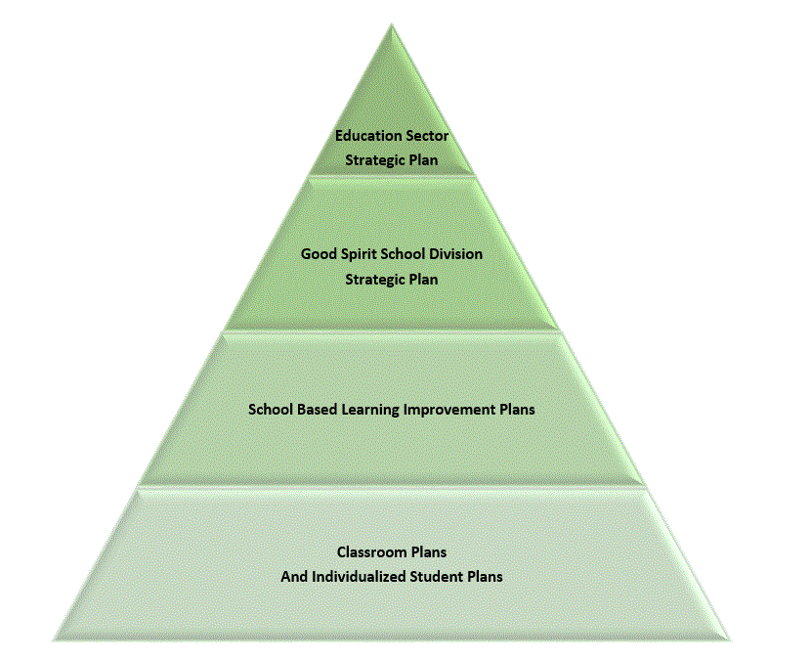

GSSD Student Success Framework
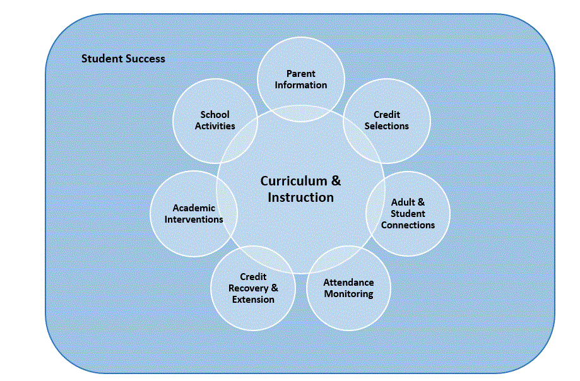
GSSD Attendance Pyramid of Interventions
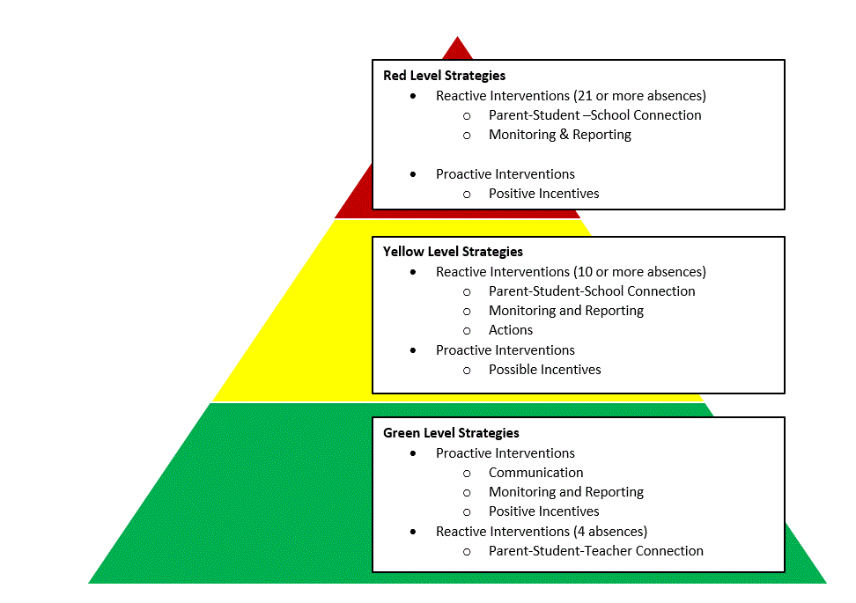
GSSD Academic Pyramid of Interventions
