Inclusive Outdoor Classroom and Swing Project - Update as of Mar. 27th, 2023
Background
- Ms. Blatter brought this project up a few years ago and did a lot of the groundwork with it.
- The CJES SCC has a motion of support for the project and has donated $5000 towards it and approved the school to do an online 50/50 fundraiser for the project. Rod has also applied for a Coop Community Spaces Grant.
- Owchar’s have donated a grain bin that is 14ft in diameter.
- Chad Nordin has already got the roof made and said it is ready to go on our call.
- Maureen Blight (GSSD - Occupational Therapist), Patti-Jo Donovan (CJES SST), Kate Devries (Mom) and Rod Steciuk (CJES Principal) met on Feb. 17th to discuss a plan so the project can be inclusive.
- Location – Maureen Blight, Rod Steciuk and Chad Rennie (GSSD Facilities) met on March 7th and the location has been approved by facilities. The location has been approved by our SCC at a prior mtg.
- GSSD Facilities has requested that we reach out to the Town and make sure a Gazebo is allowed in town and whether we need a permit. Rod contacted the T of C March 10th/2023 and found out a Development permit, Building permit and a building inspection is required. The building inspector will not approve the project unless the structure is put on cement. Brandi Z. brought Rod the permits and they are not yet completed.
- GSSD Policy states we need 3 quotes on the Concrete project (Area Prepped with a Bobcat, forms built, concrete poured to inclusive standards of zero tolerance “completely level”). The pad would have to be 24 ft square and would have a 5x25ft sidewalk to it.
Pics below are just to give an idea of what a grain bin Gazebo could look like.
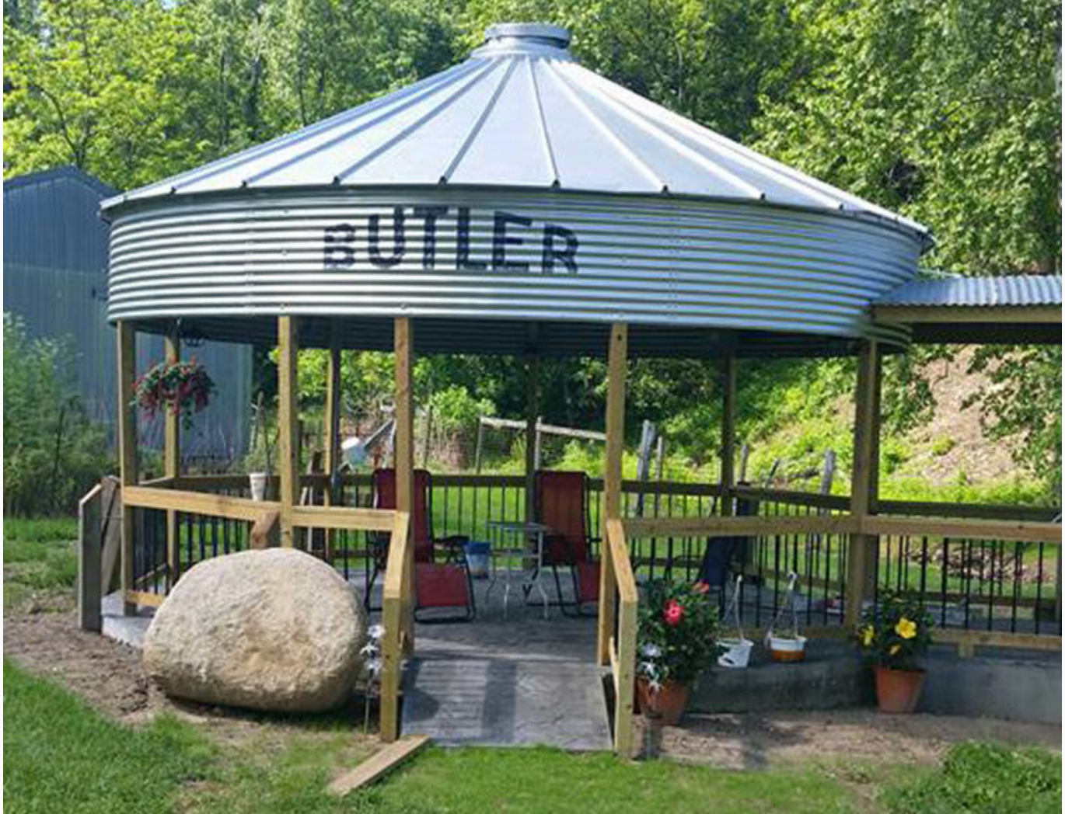

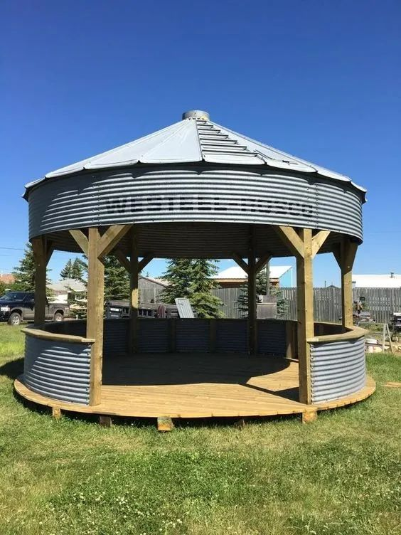

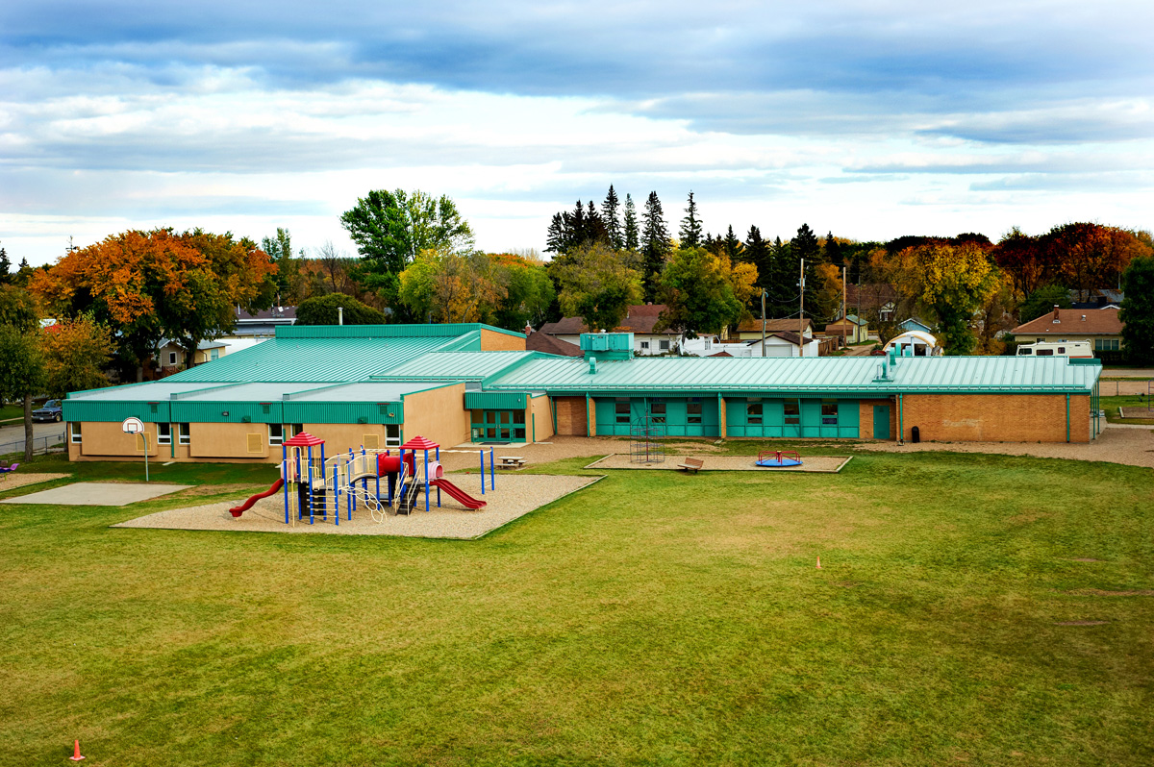
Location would be above this text box

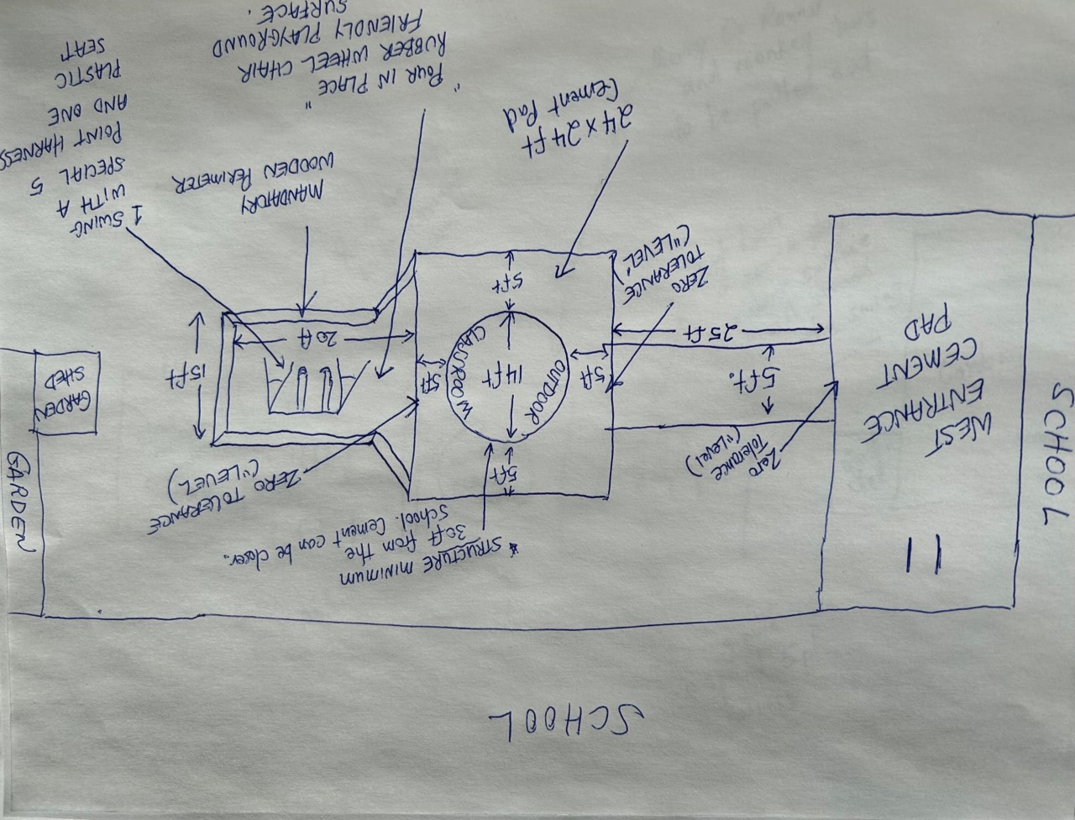
Phases:
- Phase 1 – GSSD Facilities has requested that we reach out to the Town and make sure a Gazebo is allowed in town and whether we need a permit. Rod contacted the T of C March 10th/2023 and found out a Development permit, Building permit and a building inspection is required. The building inspector will not approved the project unless the structure is put on cement. Brandi Z. brought Rod the permits and they are not yet completed.
- Phase 2 – Maureen will work on the best fit 5 point Swing with harness – Initial quote $2015.00. When this comes in it can be fastened to an existing swing structure until the “inclusive swing” phase takes place.
- Phase 3 - Remove the Merry Go Round and Monkey Bars (Kim H. said they would look after removal but want the Merry Go Round and monkey bars – This has been approved by GSSD Facilities as they are no longer code and cannot be just moved to another area on our playground.)
- Phase 4 – Concrete (Area Prepped with a Bobcat, forms built, concrete poured to inclusive standards of zero tolerance “completely level”). (*We need 3 quotes on anything over $5000) The pad would have to be 24 ft square.
- Phase 5 – Buy 6x6 lumber and whatever else is needed so it is ready to mount the grain bin/outdoor classroom. (Do not buy until ready to go as they could warp)

- Phase 6 – Put the Bin/Outdoor Classroom in place. No extras like the belly-up counter, etc. at this time. Base plates are needed to secure 6x6’s to the concrete.
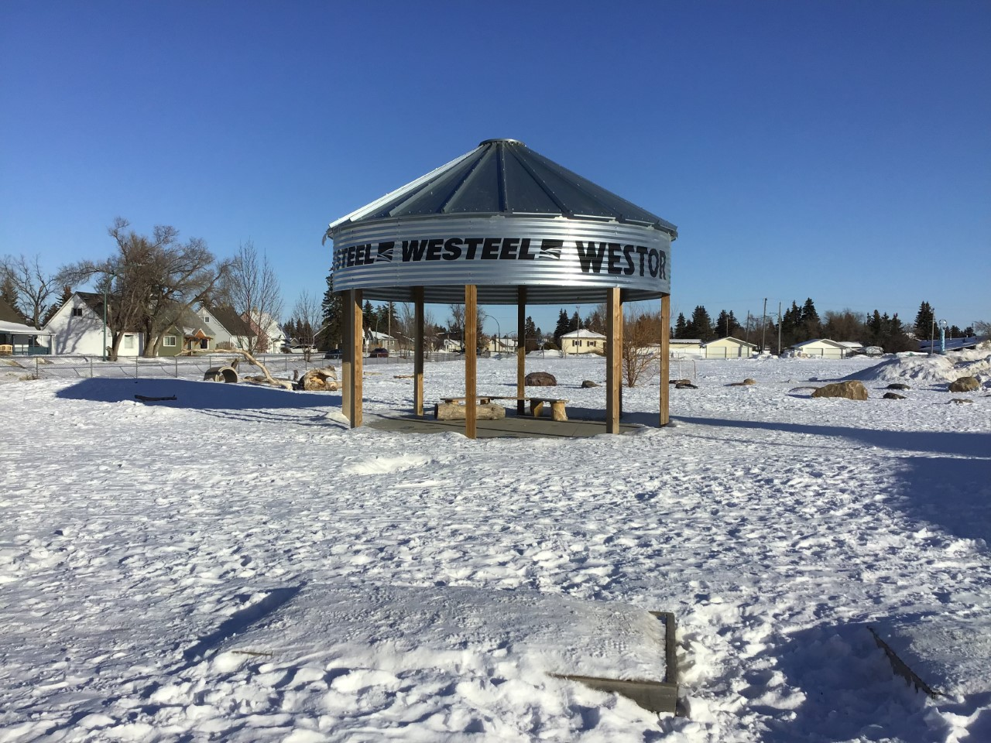
- Phase 7 – A building inspector is required to inspect the work.
- Phase 8 - Secure a double swing frame in the area directly south of the outdoor classroom. One spot that is wheel chair friendly swing and the other spot for a friend.
- Phase 9 – Pour in Place – Wheelchair friendly playground rubber ($19/square foot including the prep work). 15ft deep by 20ft wide. Chad Rennie said maintenance will put a wooden perimeter around the “pour in place”.
- Phase 10 – Landscape and seed grass around the area
- Phase 11 – Request lights on “Asset Planner/FAME” and GSSD Facilities would put in lighting that would ensure vandalism isn’t an issue.
- Phase 12 – Start adding frills to the area like a “belly-up counter”, benches, maybe large rocks around the cement pad to sit on, whatever ideas you have?
March 15th SCC Mtg. – The CJES SCC gave full support of this project and a $5000 donation. Approved CJES to do an online 50/50 or 50/50’s if it is successful.

