Inclusive Outdoor Classroom and Swing Project
Background
- Owchar’s have donated a grain bin that is 14ft in diameter.
- Chad Nordin has already got the roof made and it is ready to go on our call.
- The Outdoor Classroom will be a Grain Bin Gazebo style similar to the ones shown in the pictures below:
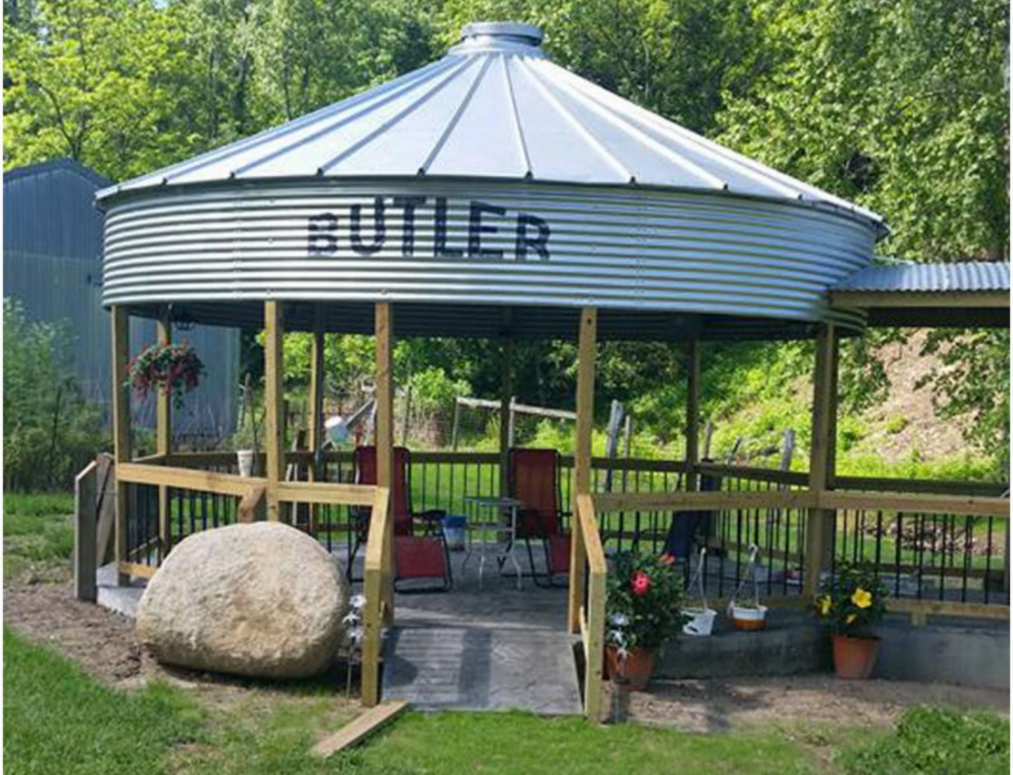
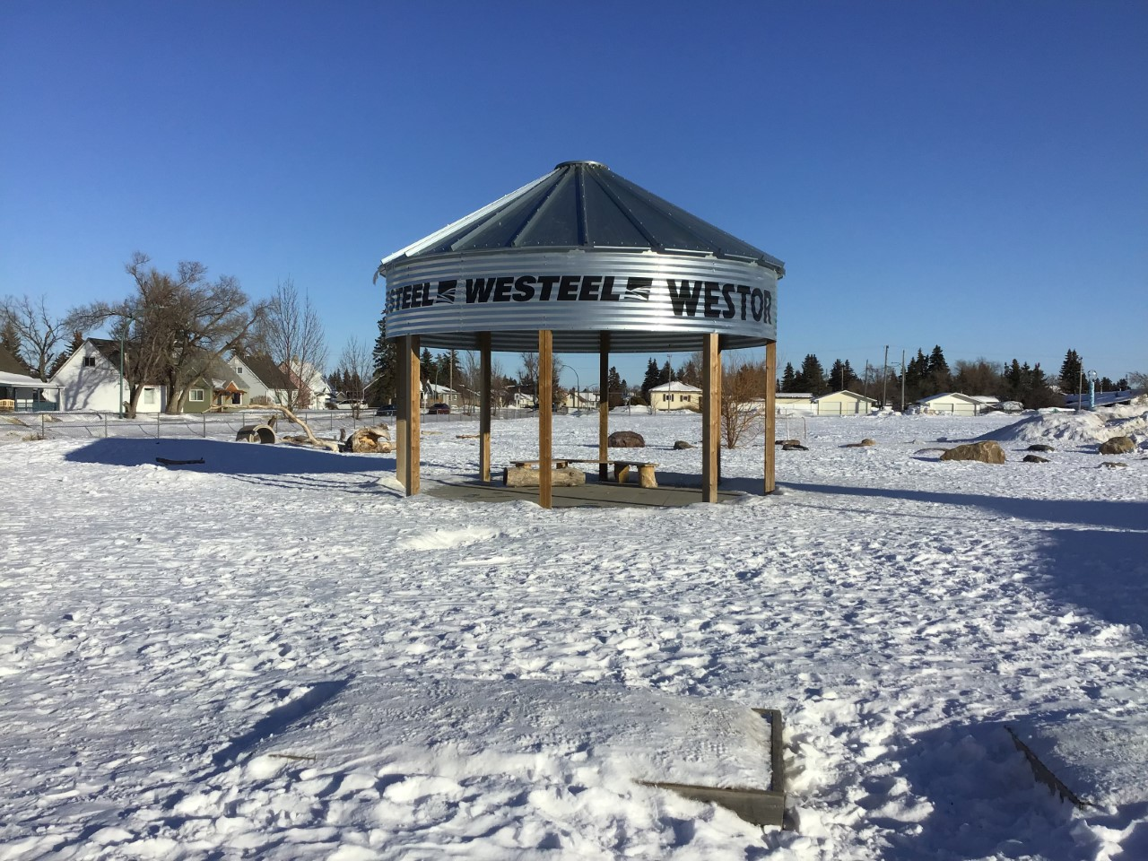

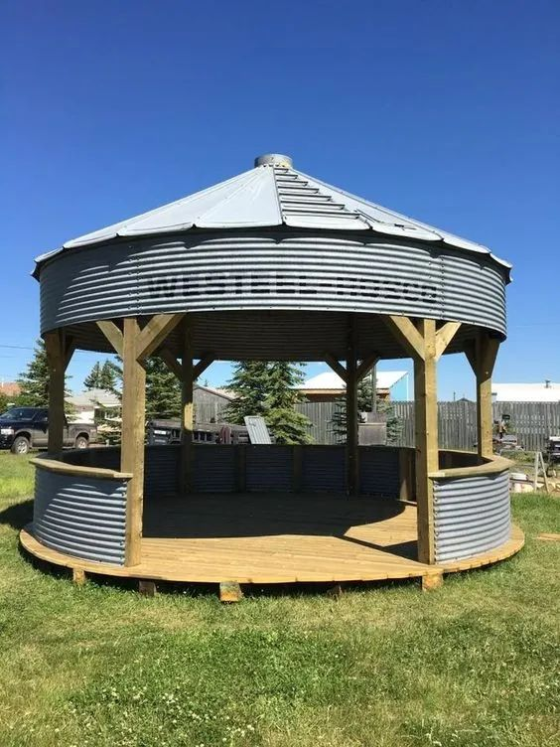

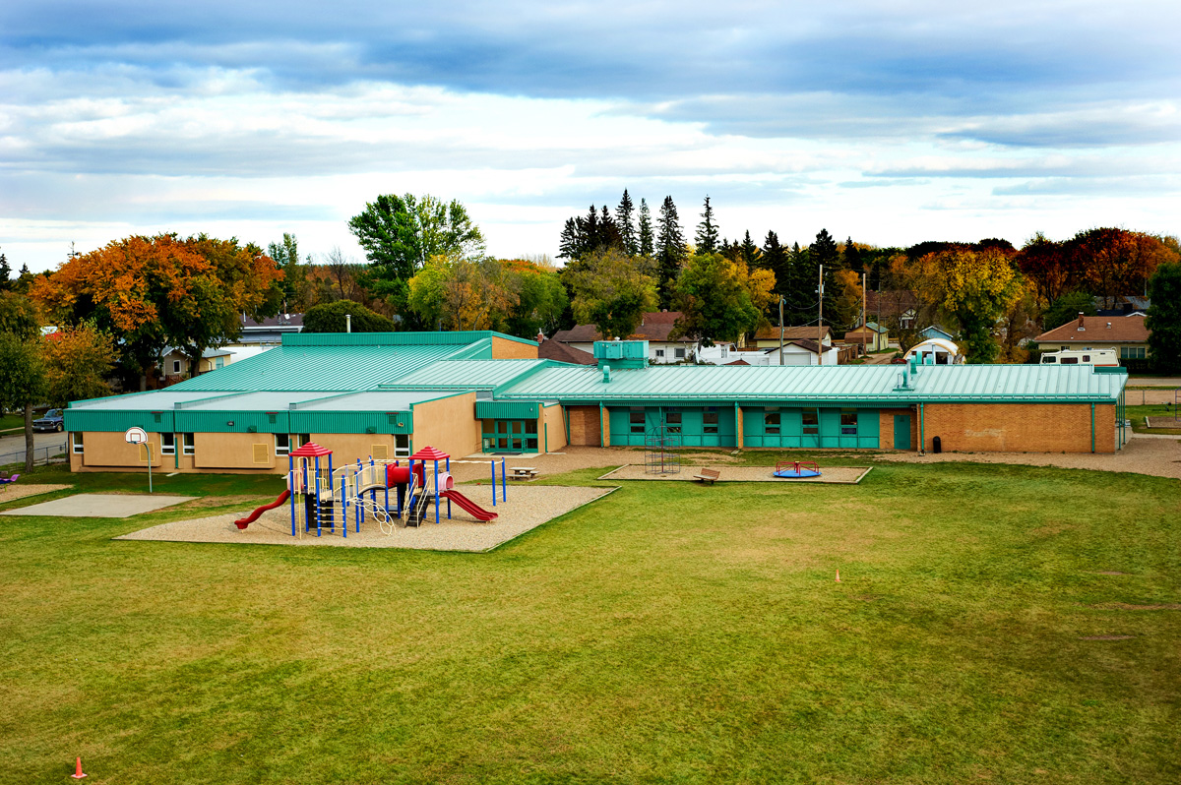

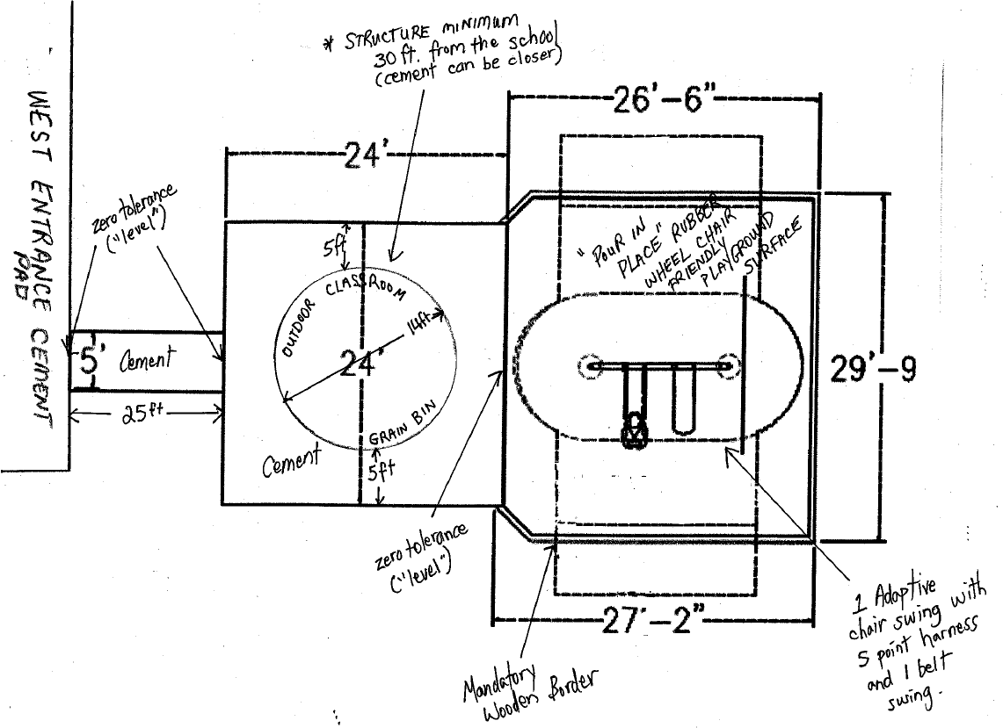
Donations to the project so far:
- The CJES SCC have donated $5000.00 towards this project
- CJES has donated over $4000.00
Grants:
- We have applied for the COOP Community Spaces Grant.
Estimated Cost of the project:
