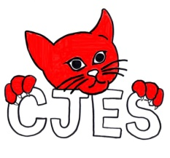 |  | Canora Junior Elementary School
May 2023 |  | REMINDER: Days 1,3, & 5 – K1 attend  Days 2,4, & 6 – K2 attend
 | Mon |  | Tue | Wed | Thu | Fri | Sat
 | 1 Day 6 |  | 2 Day 1  Pre-Order Sub Sale Day | 3 Day 2 | 4 Day 3 | 5 Day 4
 | 8 Day 5 |  | 77 9 Day 6 | 10 Day 1  CJES Staff Meeting  3:30-5:00 | 11 Day 2 | 12 Day 3
Mother’s  Day | 15 Day 4  Pre-Order Sub Sale Day  Safety Patrollers Get A Free Safety Patrol Hat Today |  | 16 Day 5 | 17 Day 6  SCC Meeting  4pm | 18 Day 1 | 19 Day 2 Playground Clean Up  1:05-2:20  Last Day To Order A House Team Shirt
 | 22  Victoria Day  NO SCHOOL |  | 23  Division PD  NO SCHOOL FOR STUDENTS | 24 Day 3  Pre-Order Sub Sale Day | 25 Day 4  Kindergarten Orientation for the 2023-2024 School Year – No school for the current K Group 2 class | 26 Day 5
 | 29 Day 6  Impact Event  9:15-11:15  In The Gym |  | 30 Day 1 | 31 Day 2

